opeX chapter meeting
  - January’s meeting
In this Topic
-Hoshin Kanri
-Why X matrix?
-Reasons To success
-The X matrix’s 5 steps

Tap here to add a caption
Having a strategy is important but what’s more important is to know how to apply it in the given time frame as time is the only resource that can’t be compensated.
In this meeting Shereen Mosallam and Mohamed Gamal talked about Hoshin Kanri Deployment tool and how a company Align objectives with the plans of middle management and work performed by employees to ensure that everyone is pulling in the same direction at the same time.
Hoshin Kanri:
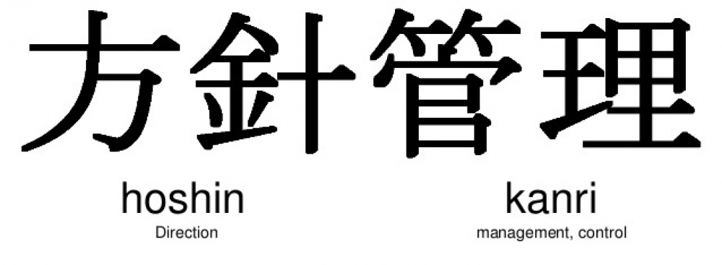
It’s a method for ensuring that the strategic goals of a company drive progress and action at every level. This eliminates the waste that comes from inconsistent direction and poor communication.
Hoshin means the direction which is the target that the company is set to.
Kanri means execution which is the strategy deployment.
Why X matrix?
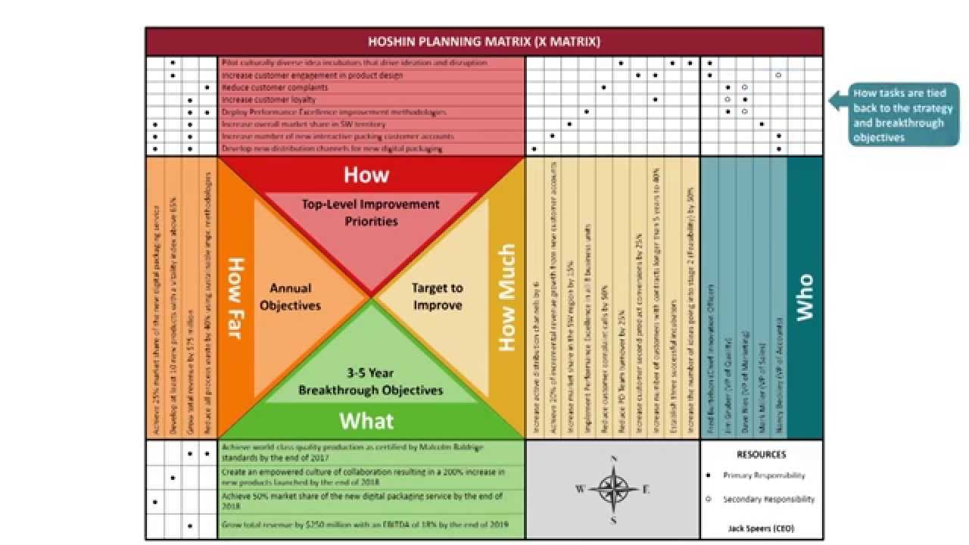

As we’re living in an era that everything is digitalized the worldwide economy now has exponential growth and that make the companies aren’t able to cope with such rapid growth. According to Harvard 70% of all the change initiatives failed to meet required targets, and that’s because of the rapid changes of the market, organizations must have the fundamental powerful tool and the people who are willing to change so they can meet their required target.
Reasons to success:
Only 30% of the organizations that are trying to cope with new technology and methodologies succeed because they have the following elements of success.
Know how:
To have a real know how for the tool or the methodology that an organization needs to apply also to know how to implement this methodology in real life according to the organization’s circumstances.
Pay for:
Implementing the change on something that will have revenue or a return on the company.
Want to:
Considered to be the hardest element of them all, it needs consistency from all the employees that are working on the tool or the methodology implemented.
The 5 steps of the X Matrix
Implementing the X Matrix happens in 5 steps that start from the top management and the executives down to the individuals to align the long-term needs with strategic initiatives and identify the most important activities along the way and list the metrics that you need to improve.
Step 1: what Break through thinking?
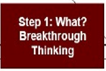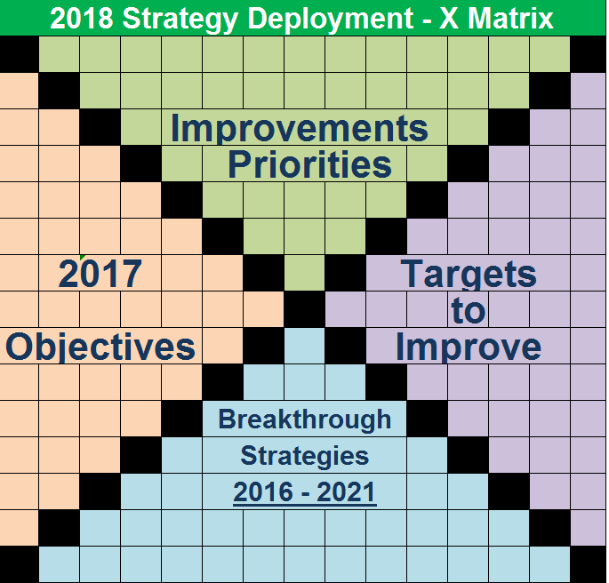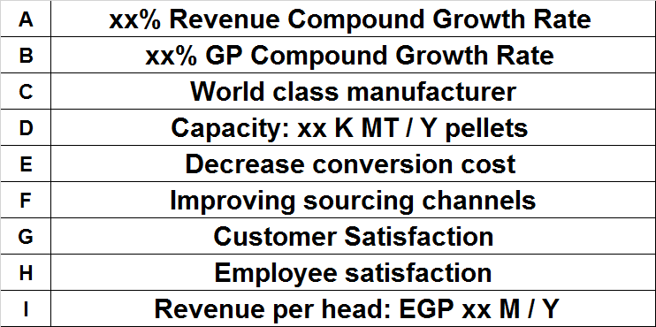

Start with the long-term goals that normally in the frame between 3 and 5 in terms of the financial figures, revenue, market presence and some strategic objectives that may include training of the employees.
This step is taken by the Board of directors and the management visions depending on their experience in the industry or the interest of the investors. This should be communicated to the middle management who will figure the tool needed to achieve the objectives.
Raya group arranged two seminars which they were focusing on the mega trends in which they wanted to know what different industries will be in 10 years and that’s important thing to have in mind while setting the 5 years goal. One of the mega trends in BariQ was 0 waste, in which the materials used has to be recycled and recyclable. That already started as governments require that specific percentage from materials has to be recyclable and that was taken in to consideration while setting the 5 years plan.

Step2: How far this year?
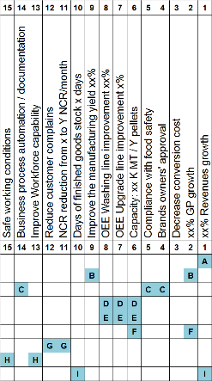

After your long-term goals are all set, prepare the most important objectives that you aim to achieve in a shorter time frame e.g 1 year. To create these, you’ll want to consider what you need to accomplish first to keep you on track and then build on from there. In this phase modifications might be applied to the main target.

Raya group business plans are created and given to each department at the end of each year in which expenses are discussed, how many employees the HR needs for this year and whether they need trainings. These plans are collected and conciliated and discussed in seminars with the heads of the departments.
Step3: How? Which key?
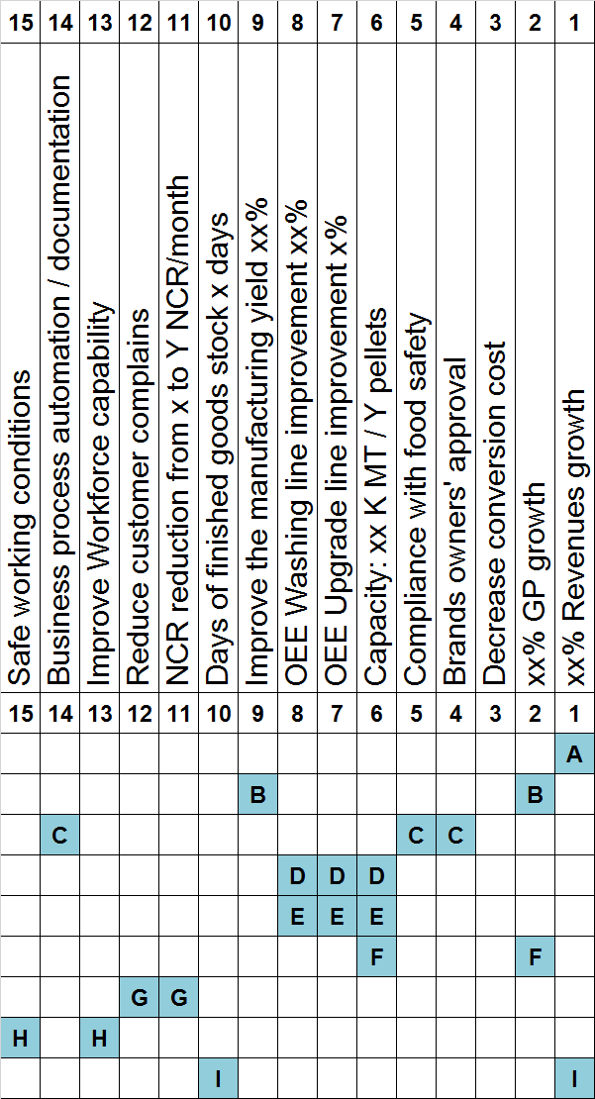
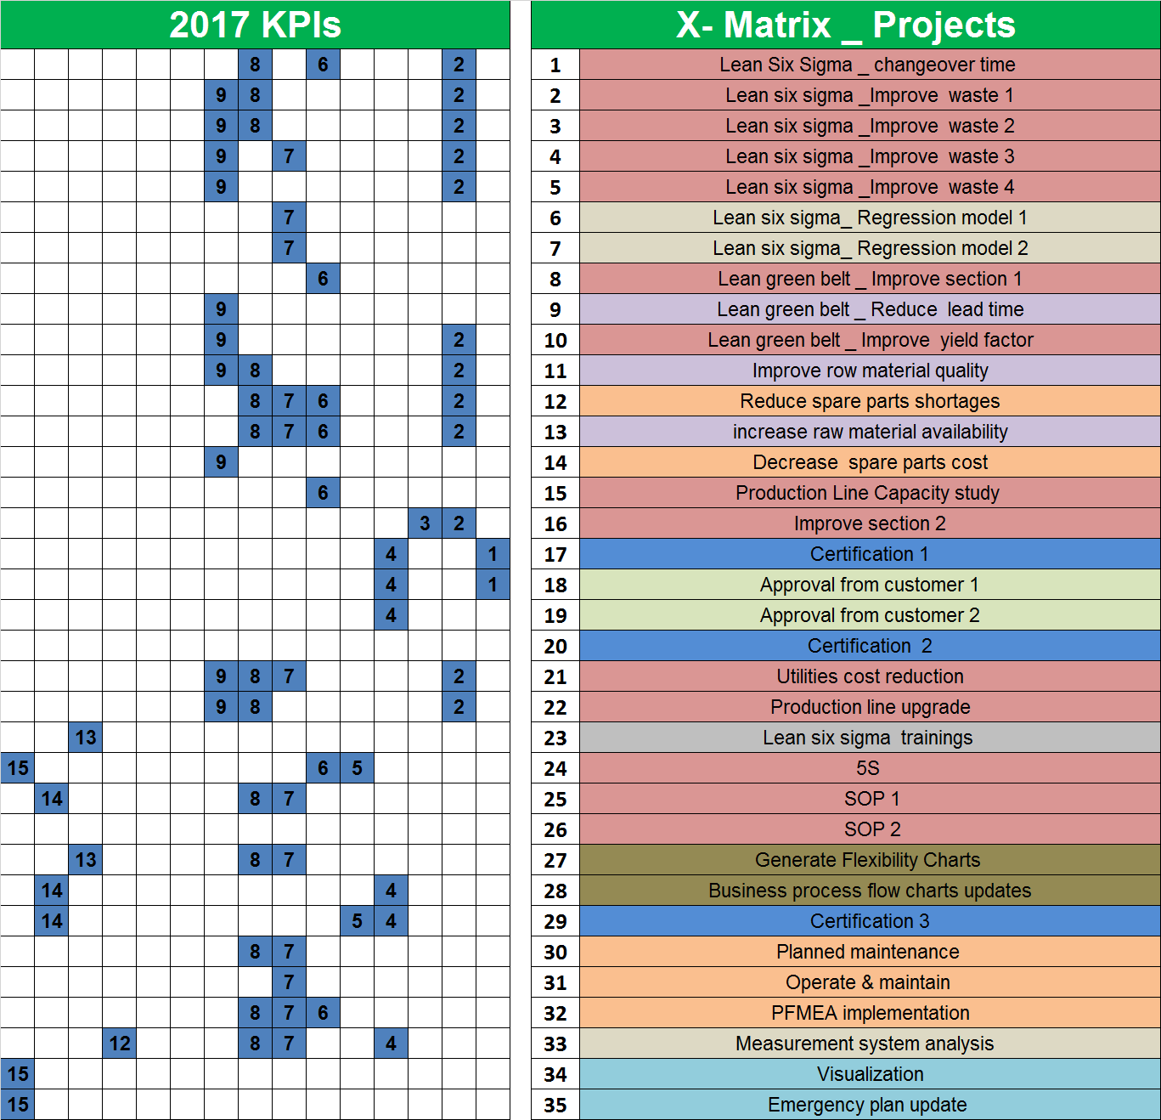
The most important activities that your team has to complete in order to achieve the short-term goals.
all departments are included in this step as every department has specific objective to achieve, the more projects you have the more involvements you’ll get. The challenge that might face the management is the resources, however you can overcome this using: FMEA, Kaizen, Regression Models, Lean projects Six Sigma projects, or LAT.

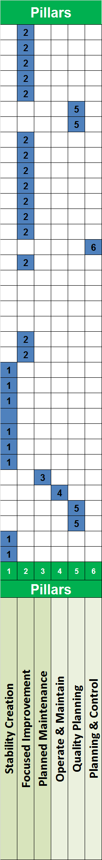
Step 4: How much? What measure?
Next, you need to know the crucial metrics that needs improvement and list them, without risking drops of morale from people whose work is not considered vital to the successful execution of the project.

Step 5: who? Resources of deployment?
Finally, you need to allocate the objectives to the resources
